Model Development Phase Template

|  |  |
| --- | --- |
| Date | 08 August 2025 |
| Skill Wallet ID | **SWUID20250188325** |
| Project Title | Predictive Pulse: Harnessing Machine Learning for Blood Pressure Analysis |
| Maximum Marks | 4 Marks |

**Initial Model Training Code, Model Validation and Evaluation Report**

The initial model training code will be showcased in the future through a screenshot. The model validation and evaluation report will include classification reports, accuracy, and confusion

matrices for multiple models, presented through respective screenshots.

**Initial Model Training Code:**

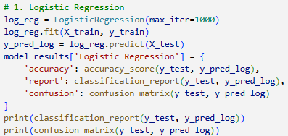

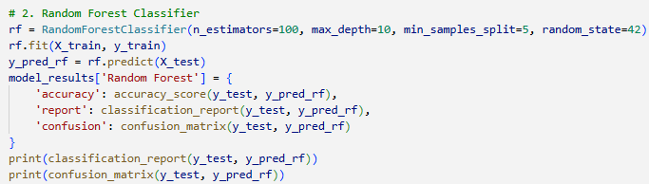

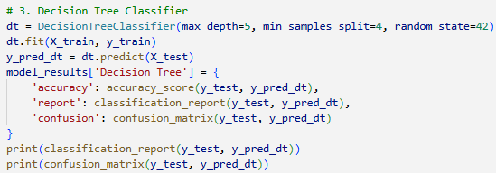

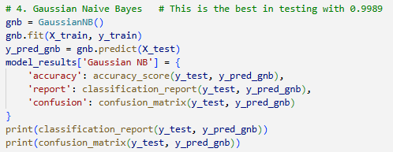

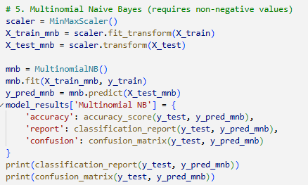

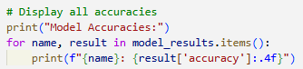

**Model Validation and Evaluation Report:**

|  |  |  |  |
| --- | --- | --- | --- |
| **Model Name** | **Classification Report Screenshot** | **F1 Score** | **Confusion Matrix Screenshot** |
| **Logistic Regression** |  | **96%** |  |
| **Random Forest** |  | **100%** |  |
| **Decision Tree** |  | **100%** |  |
| **Gaussian Navie Bayes** |  | **89%** |  |
| **Multinomial Navie Bayes** |  | **80%** |  |